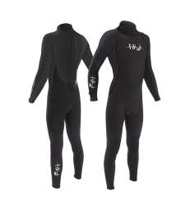
Wetsuit Size Guide

For Ghyll Scrambling we provide all specialist safety equipment, including full length winter thickness wetsuits and neoprene socks (to go inside shoes) to keep you snug. Your comfort is important to us, we will bring a few different wetsuits for each person to make sure they get one that fits well.

Please give us an approximate t-shirt/clothes size and height for each person in your party.

For children please give age and approximate height and do let us know if they are unusually big or small for their age.

Participant Name | T-Shirt/Clothes Size | Height | Weight | Age (Children only) | Sock Size

